

**E2Bar POS System**

**Windows Version**

**（User Manual）**

**V 1.0.0**

Official Website：www.e2links.com.my

**Introduction：**

E2B system is new intelligent cashier software sell goods and manage stores in cloud system online. It is suitable for many kinds of store industry such as Internet cafe, restaurant, and coffee shop. Have commodity classification, inventory statistics, member management, staff division, chain store, operation data analysis and other powerful functions. It support diversified consumption patterns, compatible with multiple payment methods, and personalized tax Settings, making the operation mode of overseas stores more flexible.

Official Website：www.e2links.com.my

**Directory**

**1. Download/Install 4**

1.Download： 4

2.Install： 4

3.Update Version: 5

**2. First Time Login 6**

4. Cashier Login Explanation： 6

**3. E2Bar Introduction： 7**

5. E2Bar Features Introduce 7

6. GST & Receipt 14

7. Compatible Hardware 15

8. Others 16

**1.Download & Install**

1.1）Step 1：

Visit：[www.e2links.com.my/e2bdownload.php](http://www.e2links.com.my/e2bdownload.php)

Click“E2B Full DOWNLOAD”

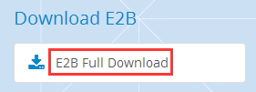

2.Install：

2.1）Find the installer in specified directory, double-click

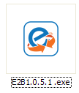

2.2）Follow the instructions to complete the installation：

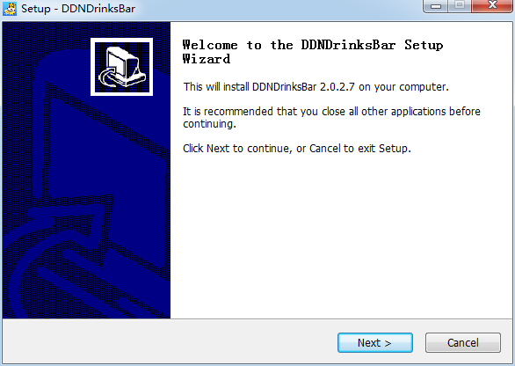 →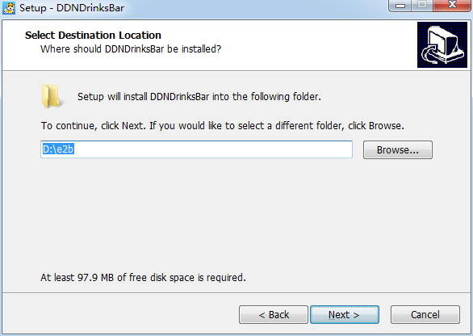

（Setup Wizard） （Installation Path）

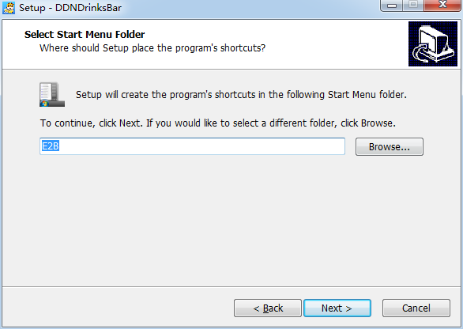→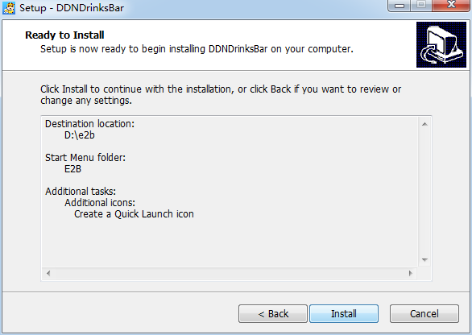

（Desktop Shortcut Name） （Confirm Install）

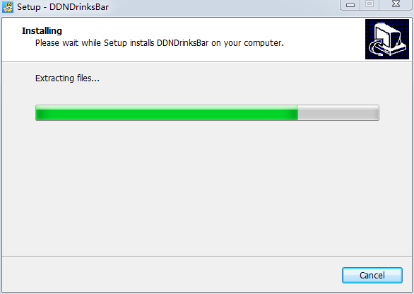→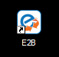

（Installing） （Install Complete）

3.Update Version:

There is 2 way to update version：

3.1）Download Latest Installer from official website

3.2）Download update from E2B login page：

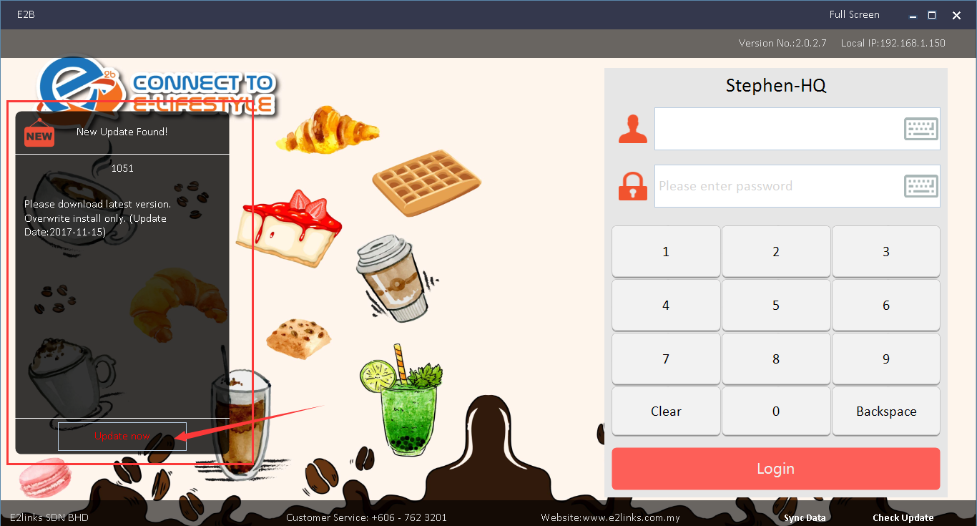

Note: Before the update, cashier must be end shift first to ensure the data has been uploaded to prevent the old data interfering or lost.

**4.First Time Login**

**4.1.Login E2B Manage ID that given from Dealer**

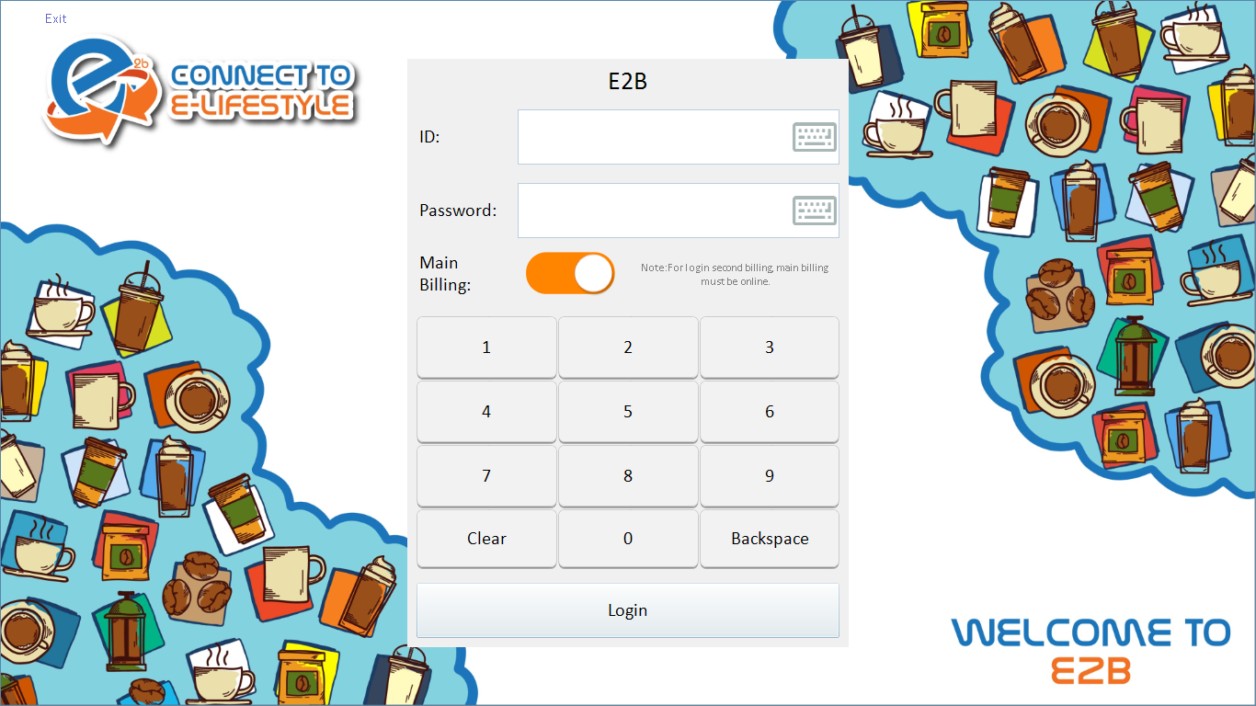

4.2）Select Branch

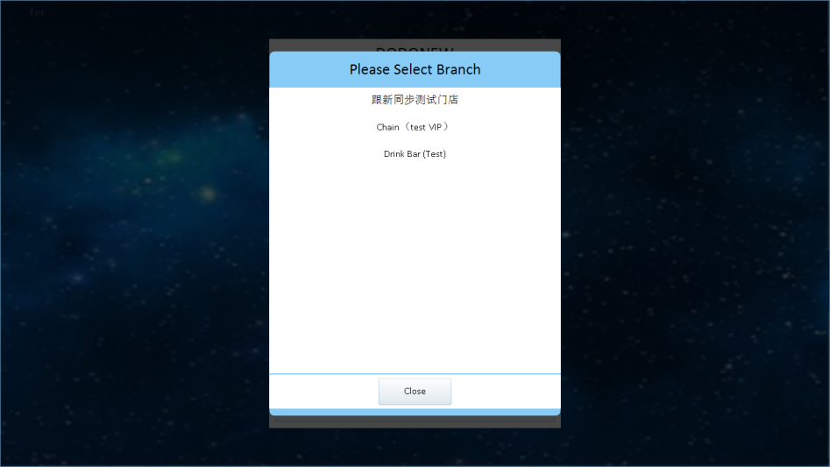

4.3）Login Cashier ID

(You have to create Cashier ID from E2B Manage before Login )

<http://e2b.e2links.com.my>

How to create Cashier ID ：<https://goo.gl/hPbi1f> (Start From 01:40)

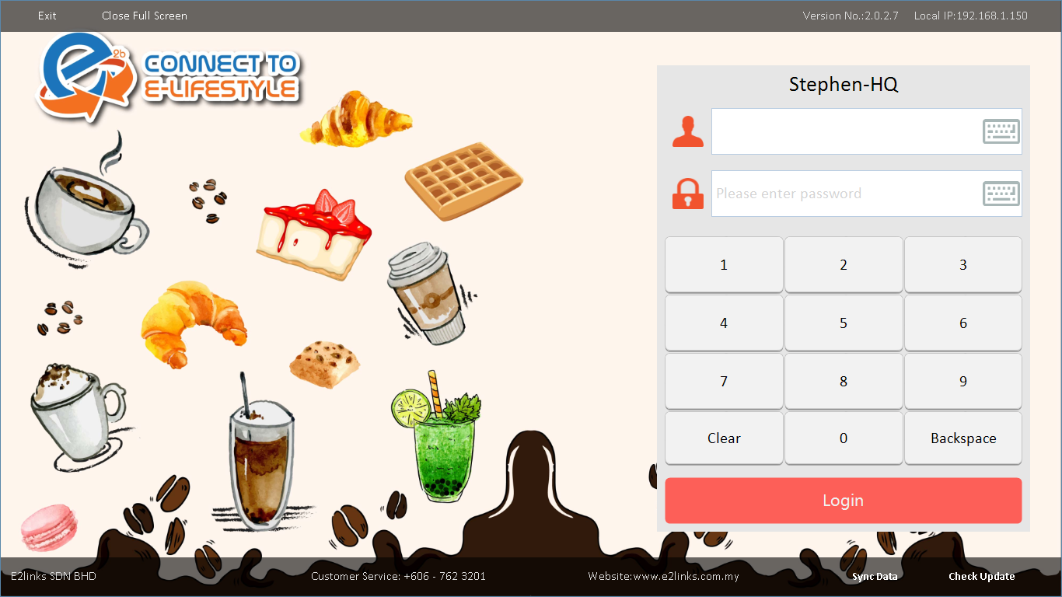

* 1. Billing Interface

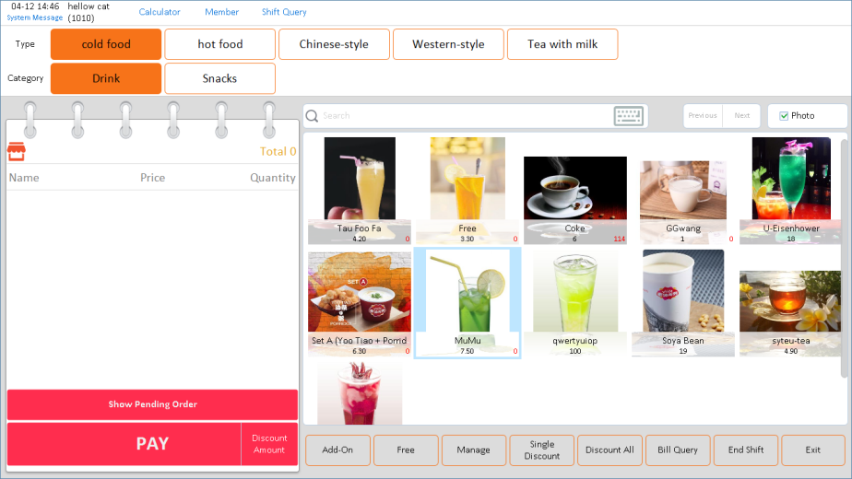

**5.E2Bar Features Introduce：**

5.1）Common Functions

A.Confirm Order Interface：

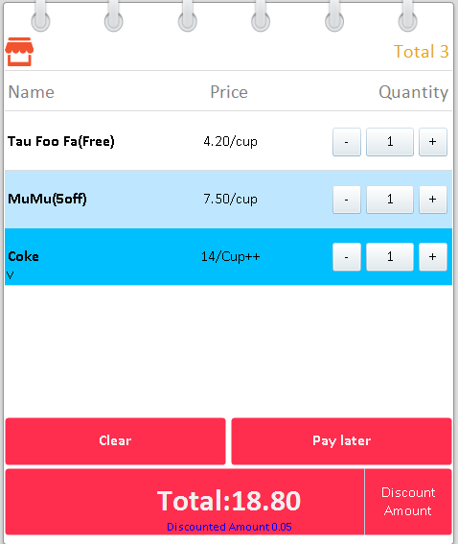Clear：Clear Order

Pay later：Keep Unpaid Bill

Discount Amount：Use for discount custom amount.

（Free）：Free Selected Item

（X Off）：Discount by percentage

Total:xx.xx ：Confirm the order & enter to payment method

Payment Method：

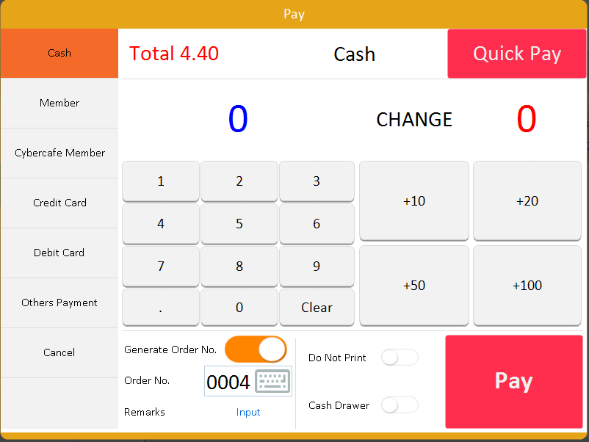

Cash：Cash Pay

Member：E2B membership,member can topup and purchase using member credit balance.

Cybercafe Member：E2B can connect with cybercafé member database,cybercafé member can use their card balance to purchase item.

Credit/Debit Card:Use for customer which pay with Credit/Debit Card

Others Payment :

Other Payment Not Yet Release：

Wechat,Alipay

Accessibility：

Generate Order NO. :On/Off Order No.

Order No. : Order No/Queue No ,it will show from receipt

Remarks : Write any note here.

Do not print ： On/Off Print

Cash Drawer： On/Off Auto Open Cash Drawer

Type & Category



Search Item Name

Next & Previous pages

View Photo：Turn On/Off view product photo



Order Menu Interface：

Item Name,Item Photo,Price,Quantity

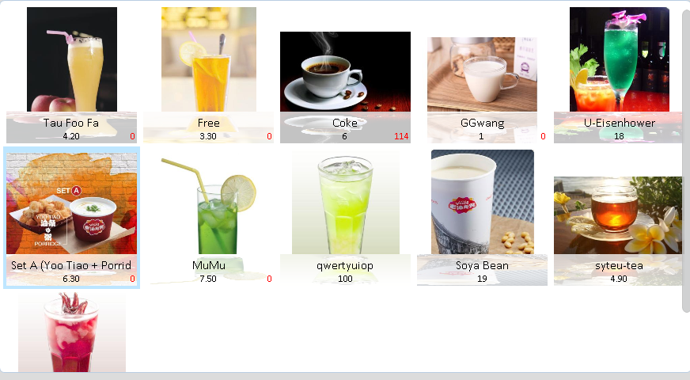

Bottom Bar Function



Add-on：Normally use for extra something Free：Free custom item

Manage：Enter to E2B Web Manage (Normally use for Stock In/Out Stock) Single Discount：Discount 1 Item Only Discount All: Discount Bill

Bill Query：Check Recent Bill

End Shift : Cashier End Shift

Exit ：Exit Program

Add On：

Add on something like more cream,less ice,more pearl

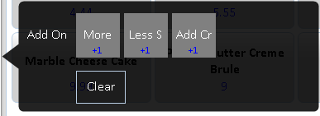

Single Discount：

Discount 1 Item Only

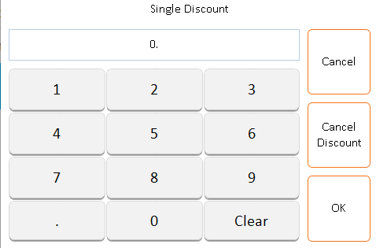

Discount All：Discount all items in one bill

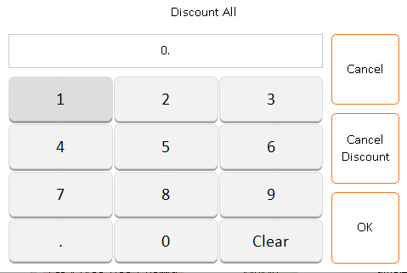

Bill Query：Check recent bill or cancel bill.

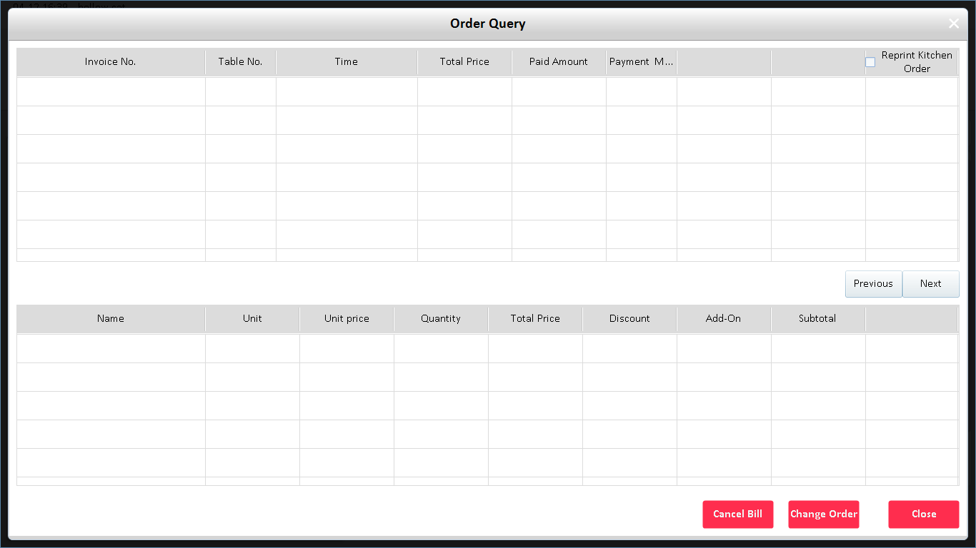

End Shift: Check current shift status or End Shift

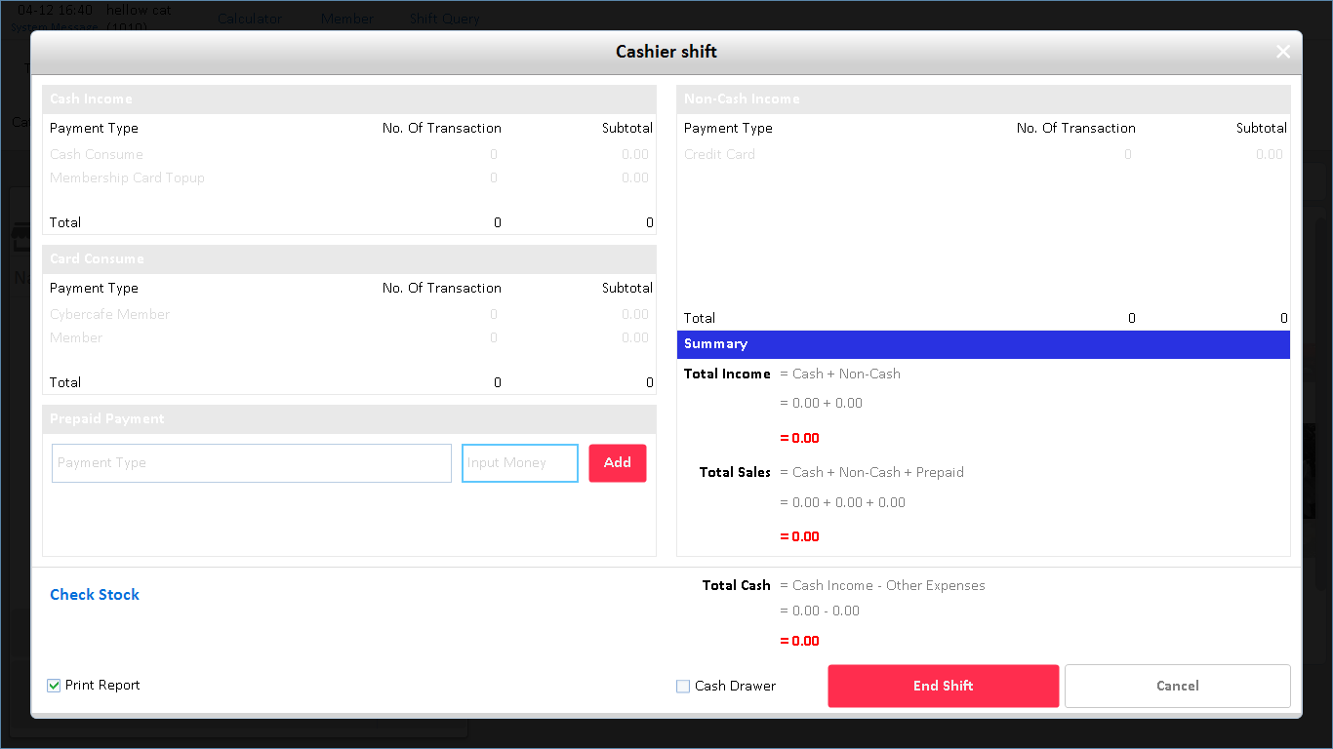

* 1. Membership Manage

A.Register member or Topup credit

B.Redemption product

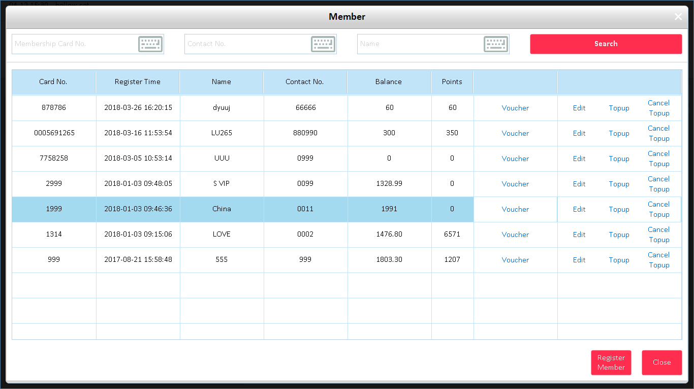

* 1. Redemption Product

A.Redeem product using points balance.

B.Seller can set the expiration date of redeem product

and also limit the redeem quantity.

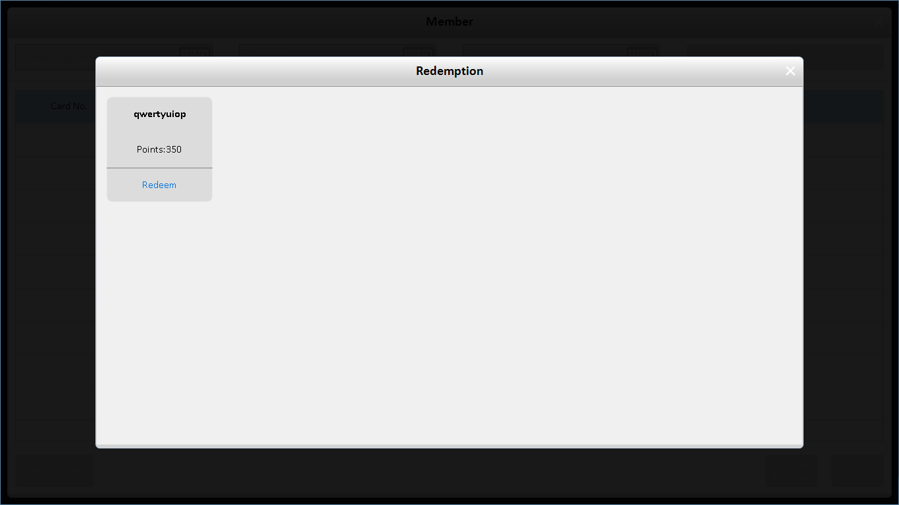

* 1. Staff Commission

Seller can set the commission on each product,Example:

Kiwi Juice – Commission：0.2

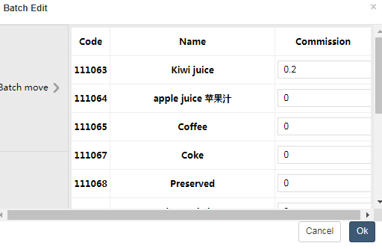

Once the staff sold the product, the report shows how much commission staff been earned. (Monthly Report)

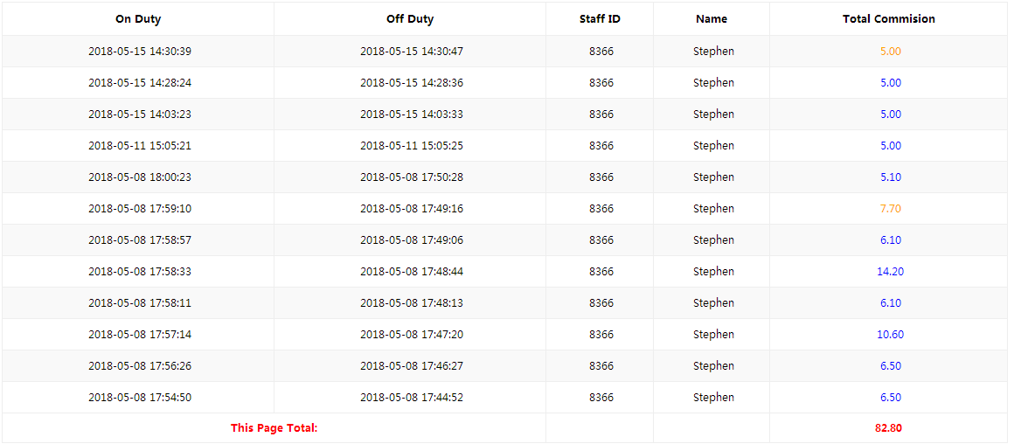

6. GST & Receipt

6.1）GST (Government Service Tax)

GST rate can be easily change from E2B Manage



Once GST has been set,the receipt will print out with GST rate in bottom.

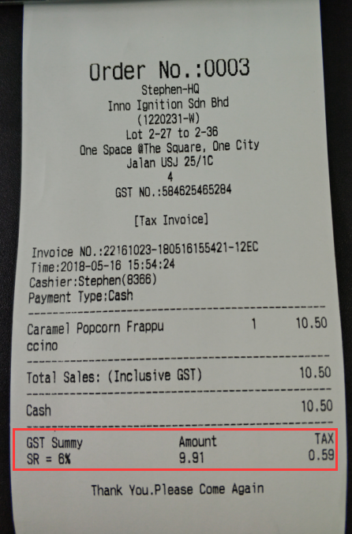

E2B manage also with monthly GST report,

you can easily download from E2B Manage

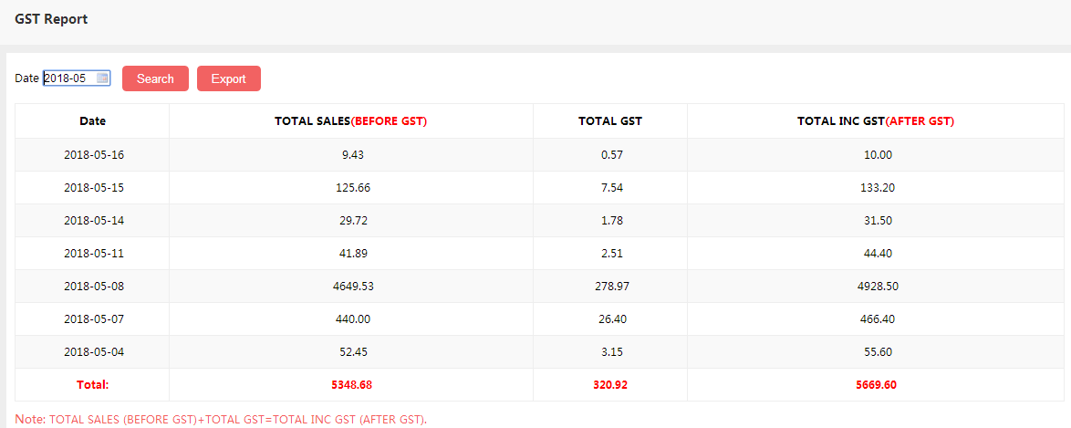

7.Compatible Hardware

Cash Drawer：

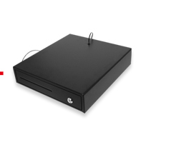

Thermal Printer

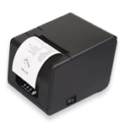

LABEL Printer ：Normally use for kitchen or stick on cup

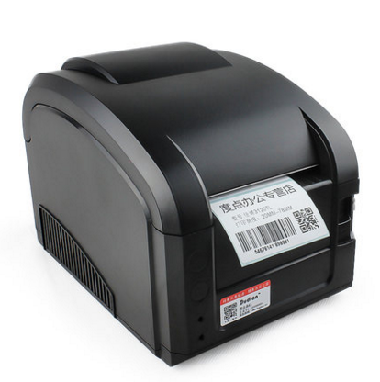

Bar Code Scanner

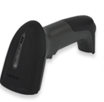

E2B Billing PC：

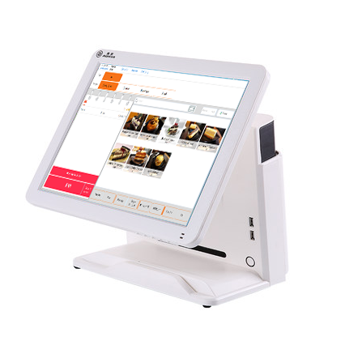

8.Others

A.E2Bar (Windows Version) can be use in offline when internet failure,

It will be synchronize to server once internet recovered.

B.Anything changes from manage cashier must be synchronize to download the data.